

DEPARTMENT OF COMPUTER SCIENCE AND ENGINEERING LAB MANUAL

CS23432 – Software Construction

(REGULATION 2023)

RAJALAKSHMI ENGINEERING COLLEGE
Thandalam, Chennai-602015

Name:
Register No:
Year / Branch / Section: Semester:
Academic Year:

INDEX

S.No. | Date | Title
1. |  | Azure Devops Environment Setup.
2. |  | Azure Devops Project Setup and User Story Management.
3. |  | Setting Up Epics, Features, And User Stories for Project Planning.
4. |  | Sprint Planning.
5. |  | Poker Estimation.
6. |  | Designing Class and Sequence Diagrams for Project Architecture.
7. |  | Designing Architectural and ER Diagrams for Project Structure.
8. |  | Testing – Test Plans and Test Cases.
9. |  | Load Testing and Pipelines.
10. |  | GitHub: Project Structure & Naming Conventions.

AZURE DEVOPS ENVIRONMENT SETUP

EXP NO: 1

Aim:
Create Epic, Features, User Stories, Task
To set up and access the Azure DevOps environment by creating an organization through the Azure portal.

INSTALLATION
- Open your web browser and go to the Azure website: https://azure.microsoft.com/en-us/get- started/azure-portal.
Sign in using your Microsoft account credentials.
If you don't have a Microsoft account, you can create one here: https://signup.live.com/?lic=1
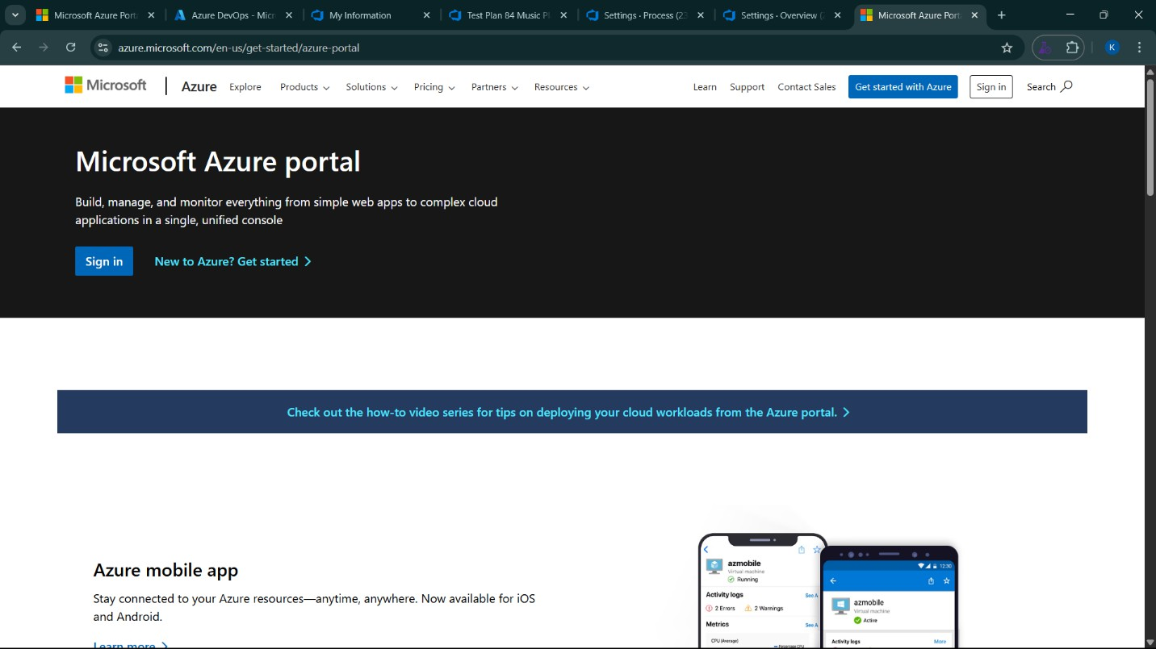

- Azure home page
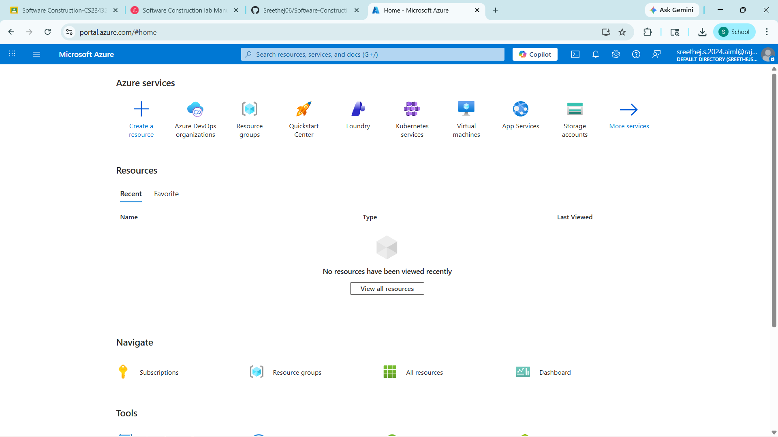
- Open DevOps environment in the Azure platform by typing Azure DevOps Organizations in the search bar.
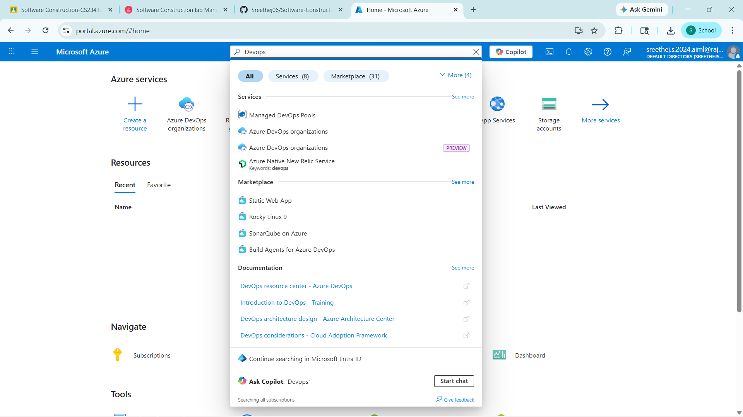

- Click on the My Azure DevOps Organization link and create an organization and you should be taken to the Azure DevOps Organization Home page.

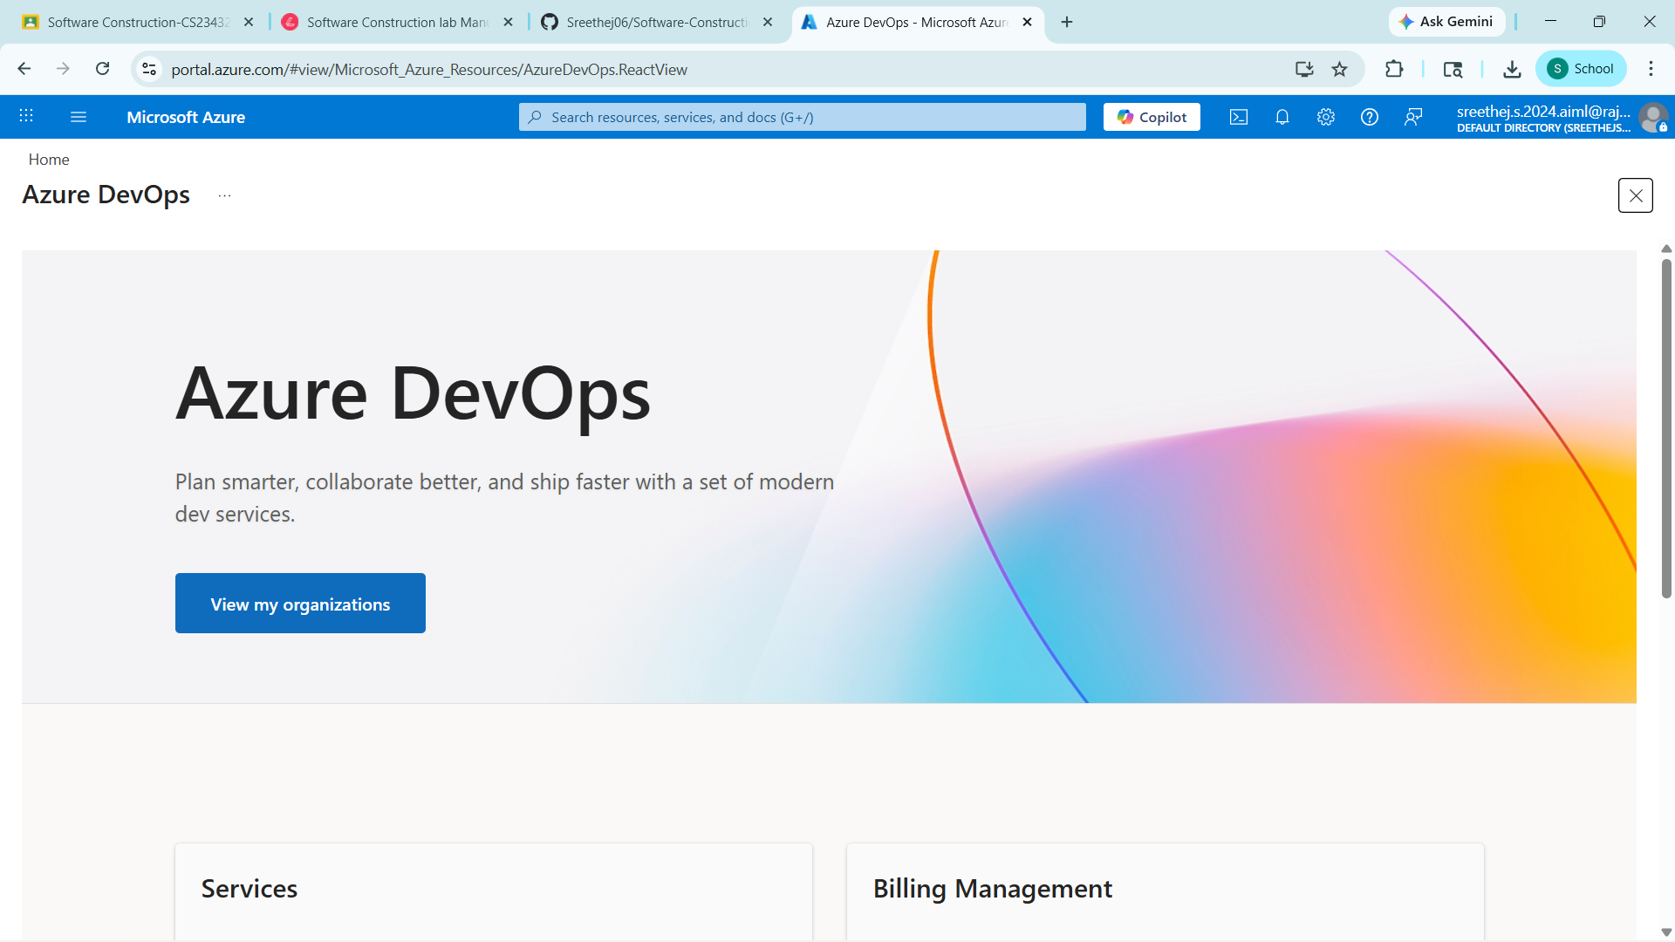

Result:
Successfully accessed the Azure DevOps environment and created a new organization through the Azure portal.

